

**John Baptizes Jesus**

**Matthew 3; Luke 3:21-22**

**Family Discussion**

* What does it mean to be a son or daughter of God?
* Imagine God saying, "[Your name], you are my dearly loved child." How do you feel about that?

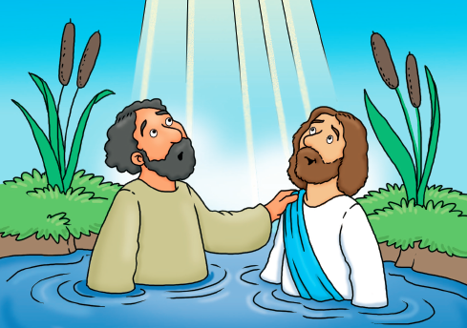

**Church Announcements**

* [Type your content here]

In today's Bible passage, John the Baptist baptizes people and preaches about Jesus. When Jesus comes, John baptizes Jesus. At Jesus' baptism, the skies open and God the Father announces that Jesus is his Son.

*"And a voice from heaven said, 'This is my dearly loved Son, who brings me great joy' "*

*(Matthew 3:17).*

**Big Blessings**

Try this at bedtime each night. Put your hand on your child's head and say, "You are my dearly loved [son or daughter], who brings me great joy."

1. Ask your child what it means to hear a blessing from you.
2. Talk about what it means that God said those words about Jesus.
3. Read Galatians 3:26 as a family. Imagine God saying your name and telling you you're his son or daughter and that you bring him joy.

**We're Alike**

Jesus is God's Son, so they are alike in many ways. See what similarities you can spot with household items.

1. Gather 10-20 random items from around your house.
2. Have family members take turns selecting two objects from the pile and saying ways they are alike. For example: They're both made of plastic; they're both kitchen tools.
3. Talk about these questions:

**• What are some ways each of us is like our parents?**

**• What do you know about Jesus now? How does that help you know about his Father, God?**